# Coding Hygiene of the Day

As all facilitators of this DeCal can testify, there is an epidemic among scientists! It is, put simply, rampant *bad coding hygiene*. It stinks. You know someone has bad coding hygiene when someone puts code in front of you and you still can’t tell what it does, even after minutes to hours of meticulous analysis. What does it look like? Feast your eyes.

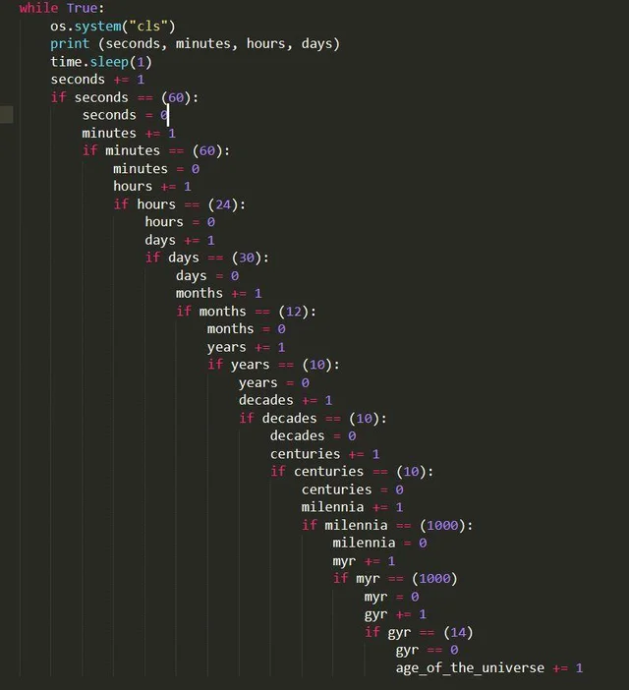

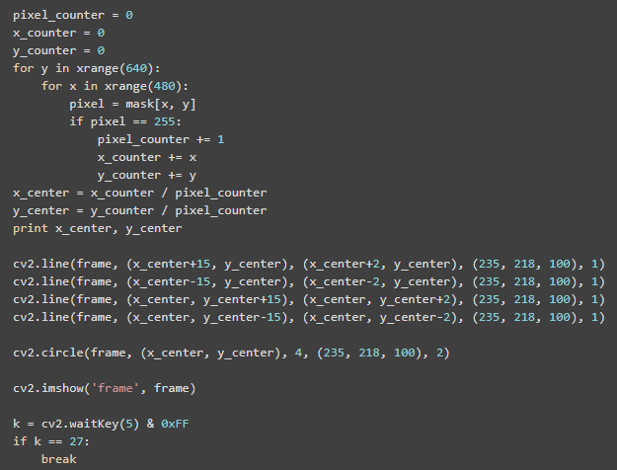

I’m sorry we had to show you that, but we can’t let you remain ignorant. Anyways, forget about bad code. You know what it feels like to read good code? Like enjoying a good book. Like scoring one point above someone you respect on a test. Like getting a burrito from La Burrita that actually tastes like it’s from SoCal. Good coding hygiene is so, so heavenly and also benefits everyone in the long run. So what is good coding hygiene? It’s time for our first coding hygiene tip![1]

## **Tip #1: Create Meaningful Variable Names**

Yes, when defining variables, give them names that will clearly communicate what values are bound to them. Don’t you hate it when professors write down variables like x, y, ∆, 𝚿, or 𝄞 and don’t explain what they mean? Not only is it hard for you to use what you wrote, but it also makes it difficult to debug issues if we can’t identify what parts of your code are doing. This means people like the facilitators who love you and want you to succeed will have trouble helping you. :( Create meaningful names!

|  |  |
| --- | --- |
| Examples of Meaningful Names | Examples of Non-Meaningful Names |
|  |  |

## **Tip #2: Comment is Code**

We haven’t explained what comments are yet in this course, but you have seen them before. It’s anything you type after a hashtag in Python, and it has absolutely no impact on your code.



Comments are generally used to clarify code that might be confusing to read. That being said, “Comment is Code” is the notion that code should be so self-explanatory that comments are not needed.

In this course, we are not so zealous as to force you to sit for hours thinking of creative variable and function names to make any and all comments useless...but it’s just food for thought. Which one looks easier to read? The first definition or the second?

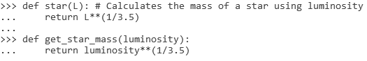

It’s up to you to decide which style you prefer!

1. **DISCLAIMER:** Maintaining good coding hygiene is hard and no one is perfect. Even we are still working on it. But it’s like recycling--the far-in-the-future you will appreciate it.